Find the area of each shape

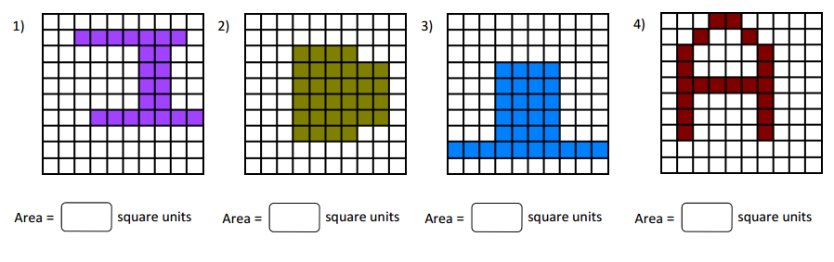
Find the area of the shapes in each grid. Fill in the box with appropriate symbol <, > or = in each problem.
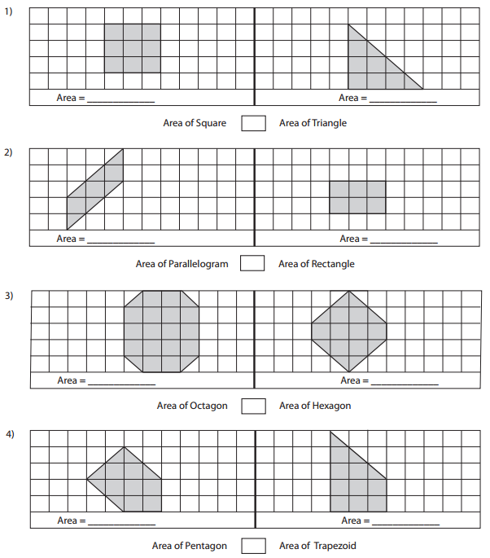

Find the area for each triangle

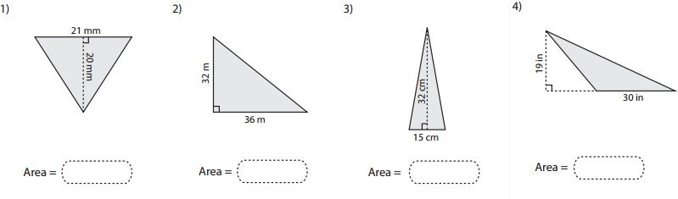

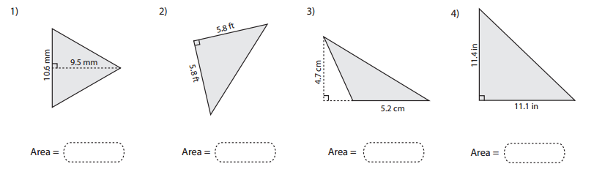

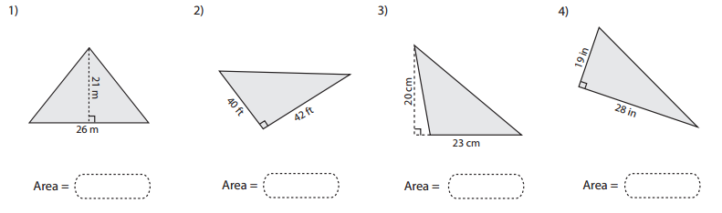

Find the base or height of each triangle
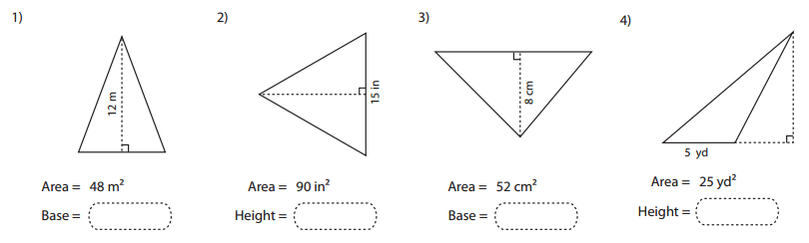

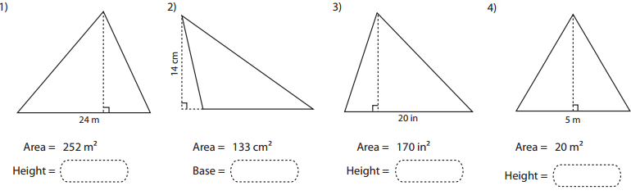

Identify the smallest and largest angle for each triangle
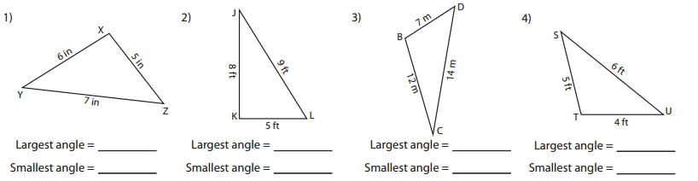

Identify the shortest and longest side for each triangle

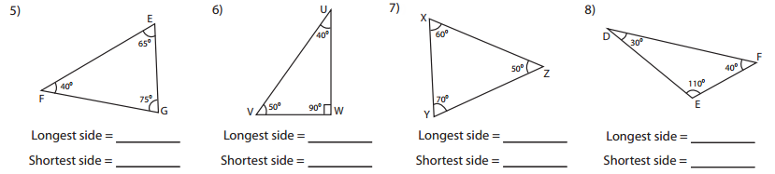

Applying triangle inequality theorem, identify whether the triangle is possible or not possible with the given side measures.
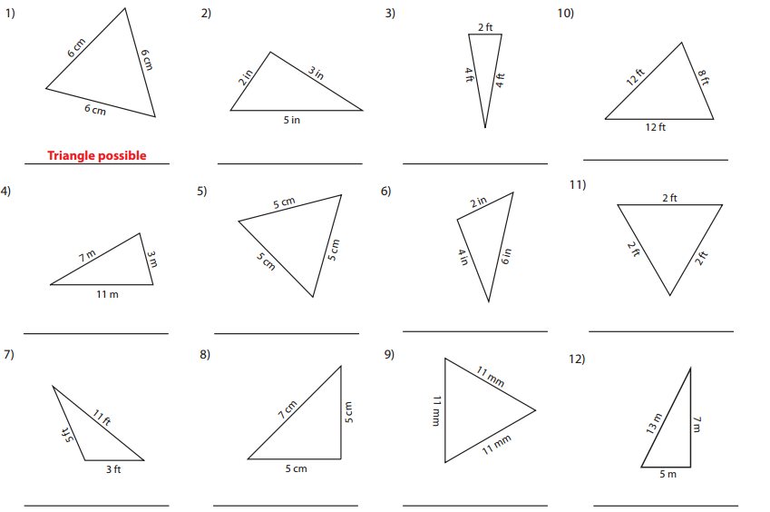

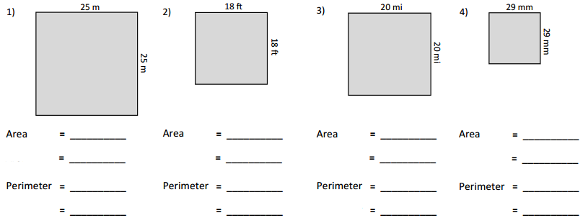

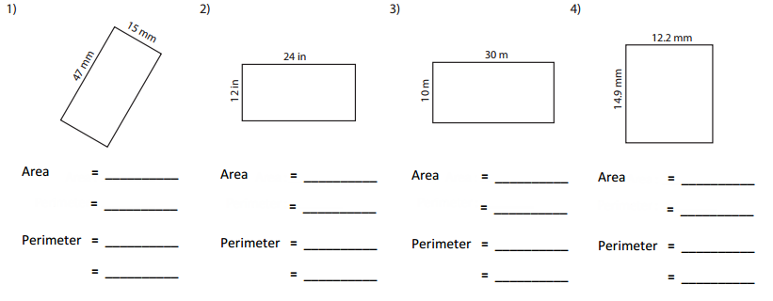

Find the area of each quadrilateral
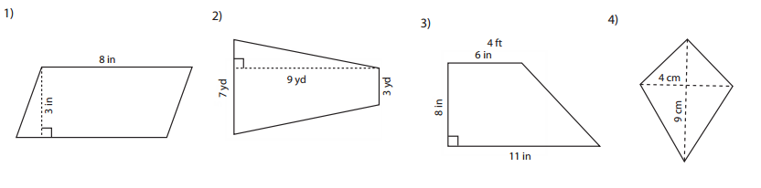

Find the perimeter of each quadrilateral
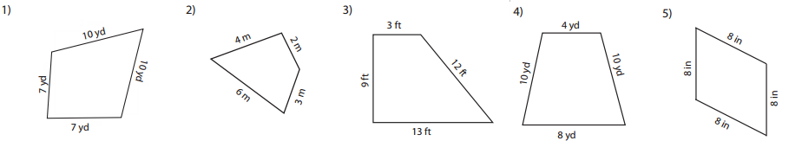

Find the area of each irregular shape
